Directions to Market Decisions Research:

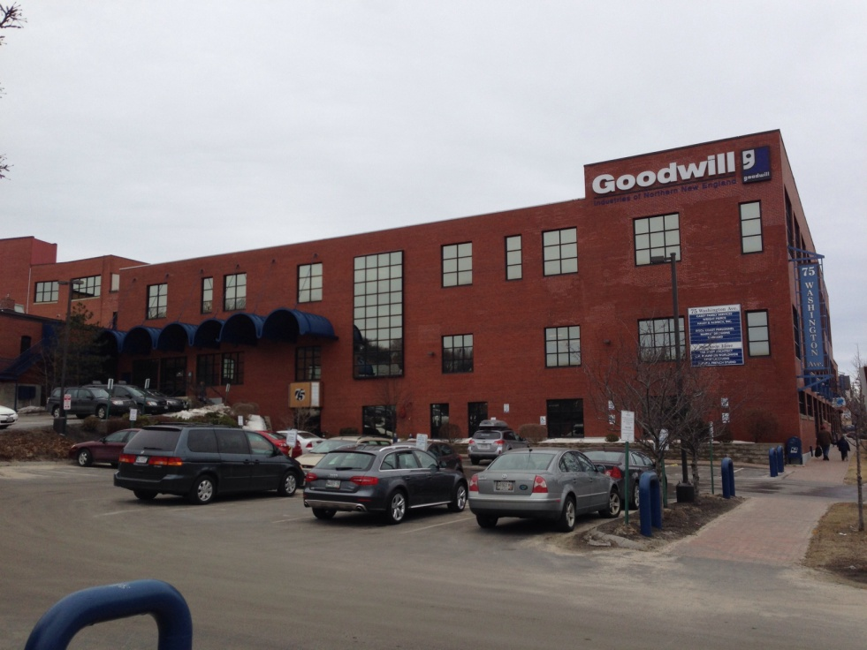

From the South:
- Take I-95/Maine Turnpike North.
- Take Exit 44 onto I-295 to Portland – you will have to pay a toll.
- Take Exit 7 (Franklin Street) off I-295 – this will put you on Franklin Arterial.
- Follow Franklin Arterial through 2 traffic lights.
- At the third light, take a left onto Cumberland Avenue and make sure to stay in the right hand lane.
- Follow Cumberland Avenue for 0.2 miles.
- Take a left onto Washington Avenue.
- After 0.2 miles you will see our building on the right hand side. Our address is 75 Washington Avenue – in the old J.J. Nissen Bakery Building, a three story brick building. (You will see “Goodwill” up at the top of building.)
- You can park anywhere in the parking lot adjacent to our building AFTER 5:00 pm (ignore the signs for other businesses). If there is not a spot available, please park on the side of street or you can park in a satellite lot just down the street from our building. This lot is 100 feet beyond Market Decisions’ building, towards I-295. It is located at 107 Washington Avenue and surrounds a brick “State of Maine” building.
- Go through the front door OF THE SECOND FLOOR (there is a blue awning overhead) and our office is the first door on the left (Suite 2C) – glass doors.

From the North:
- Take I-295 to Portland.
- Take Exit 8 - Washington Avenue.
- Our building is approximately 0.7 miles down Washington Ave on the left hand side. Our address is 75 Washington Avenue - in the old J.J. Nissen Bakery Building, a three story brick building. (You will see “Goodwill” up at the top of building.)
- You can park anywhere in the parking lot adjacent to our building AFTER 5:00 pm (ignore the signs for other businesses). If there is not a spot available, please park on the side of street or you can park in a satellite lot just down the street from our building. This lot is 100 feet beyond Market Decisions’ building, towards I-295. It is located at 107 Washington Avenue and surrounds a brick “State of Maine” building.
- Go through the front door OF THE SECOND FLOOR (there is a blue awning overhead) and our office is the first door on the left (Suite 2C) – glass doors.

From the Portland Jetport:
- Make a right coming out of the airport onto Outer Congress Street.
- Follow Congress Street for 2 miles, through six traffic lights.
- After the sixth traffic light, bear right onto the I-295 North entry ramp (Falmouth).
- Take Exit 7 (Franklin Street) off I-295– this will put you on Franklin Arterial.
- Follow Franklin Arterial through 2 traffic lights.
- At the third light, take a left onto Cumberland Avenue and make sure to stay in the right hand lane.
- Follow Cumberland Avenue for 0.2 miles.
- Take a left onto Washington Avenue.
- After 0.2 miles you will see our building on the right hand side. Our address is 75 Washington Avenue – in the old J.J. Nissen Bakery Building, a three story brick building. (You will see “Goodwill” up at the top of building.)
- You can park anywhere in the parking lot adjacent to our building AFTER 5:00 pm (ignore the signs for other businesses). If there is not a spot available, please park on the side of street or you can park in a satellite lot just down the street from our building. This lot is 100 feet beyond Market Decisions’ building, towards I-295. It is located at 107 Washington Avenue and surrounds a brick “State of Maine” building.
- Go through the front door OF THE SECOND FLOOR (there is a blue awning overhead) and our office is the first door on the left (Suite 2C) – glass doors.

Lost? Call 207-767-6440 x107

